Business Requirement Document

*for*

**OpenSourceDataVisualization**

Presented by:Tribe-H

Directed by: Dinesh Behra

| Roles | Name |
| --- | --- |
| Documentation | Salinee Nayak, Sivangi Shingade, Sarika |
| Design | Bhanudas kajale, Bhagyalaxmi Malipatil, Akashata Pujari |
| Development | Atharv Joshi, Nagraj Yache, Salinee Nayak |
| Testing | Krishna Koustib |

**PROJECT_TITLE** : OPEN SOURCE DATA VISUALIZATION

**PROJECT SUMMARY** :

Data visualization is the graphical representation of information and data. By using [visual elements like charts, graphs, and maps](https://www.tableau.com/data-insights/reference-library/visual-analytics), data visualization tools provide an accessible way to see and understand trends, outliers, and patterns in data.

In the world of Big Data, data visualization tools and technologies are essential to analyze massive amounts of information and make data-driven decisions.

It can be used by teachers to display student test results, by computer scientists exploring advancements in artificial intelligence(AI) or by executives looking to share information with stakeholders.

**PROBLEM STATEMENT** :

1. Create a Data visualization system using open source services and methods, where users can upload a file and expect different charts or graphs based on the data.
2. Misleading Color Contrast:

In data visualization, high degrees of color contrast may cause viewers to believe that value disparities are greater than they really are.

Designer Takeaways:

* Color is more than a way to differentiate between data series.
* High-contrast color pairings cause viewers to perceive greater degree of data disparity.

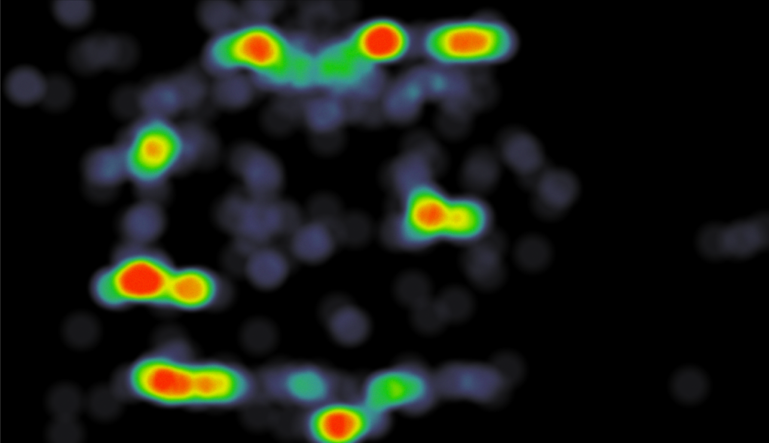

1. Too much Data

When data visualizations include too much data, information overwhelms, and data melts into a graphic soup that most viewers can’t stomach.

Designer Takeaways:

* Information overload applies to data visualization. If too much is present at once, viewers zone out.
* It can be more effective to communicate data with multiple data visualizations.

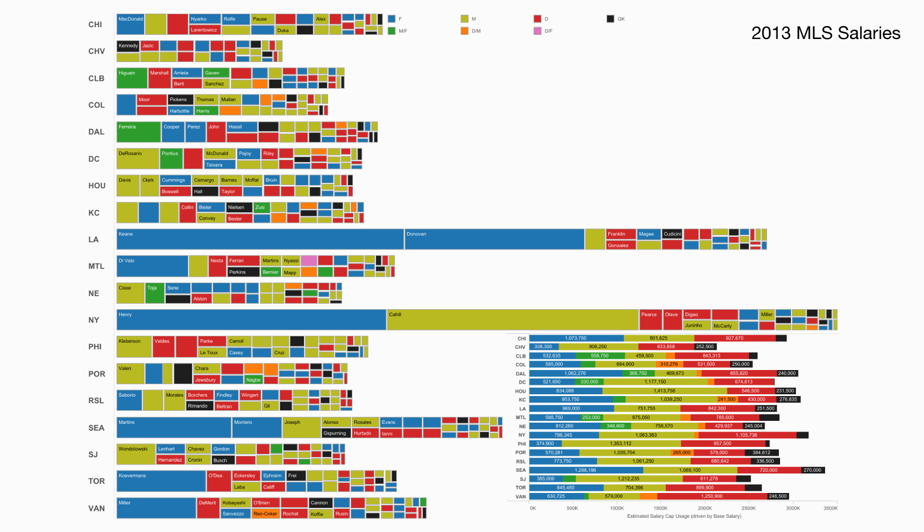

1. Omitting Baselines and Truncating Scale

Data varies, sometimes widely, like when measuring levels or voting habits according to geographical regions. In an effort to make visualizations more dramatic or aesthetically pleasing, designers may choose to manipulate scale values on graphs.

Common examples are omitting the baselines or starting Y-axis somewhere above zero to make data differences more pronounced.

Another example is truncating the x value of a data series to make it seem comparable to lower-value series.

Designer Takeaways:

* Aesthetic appeal is subordinate to accurate data representation.
* Omitting baselines and truncating scales to intentionally exaggerate or minimize data disparities is unethical.

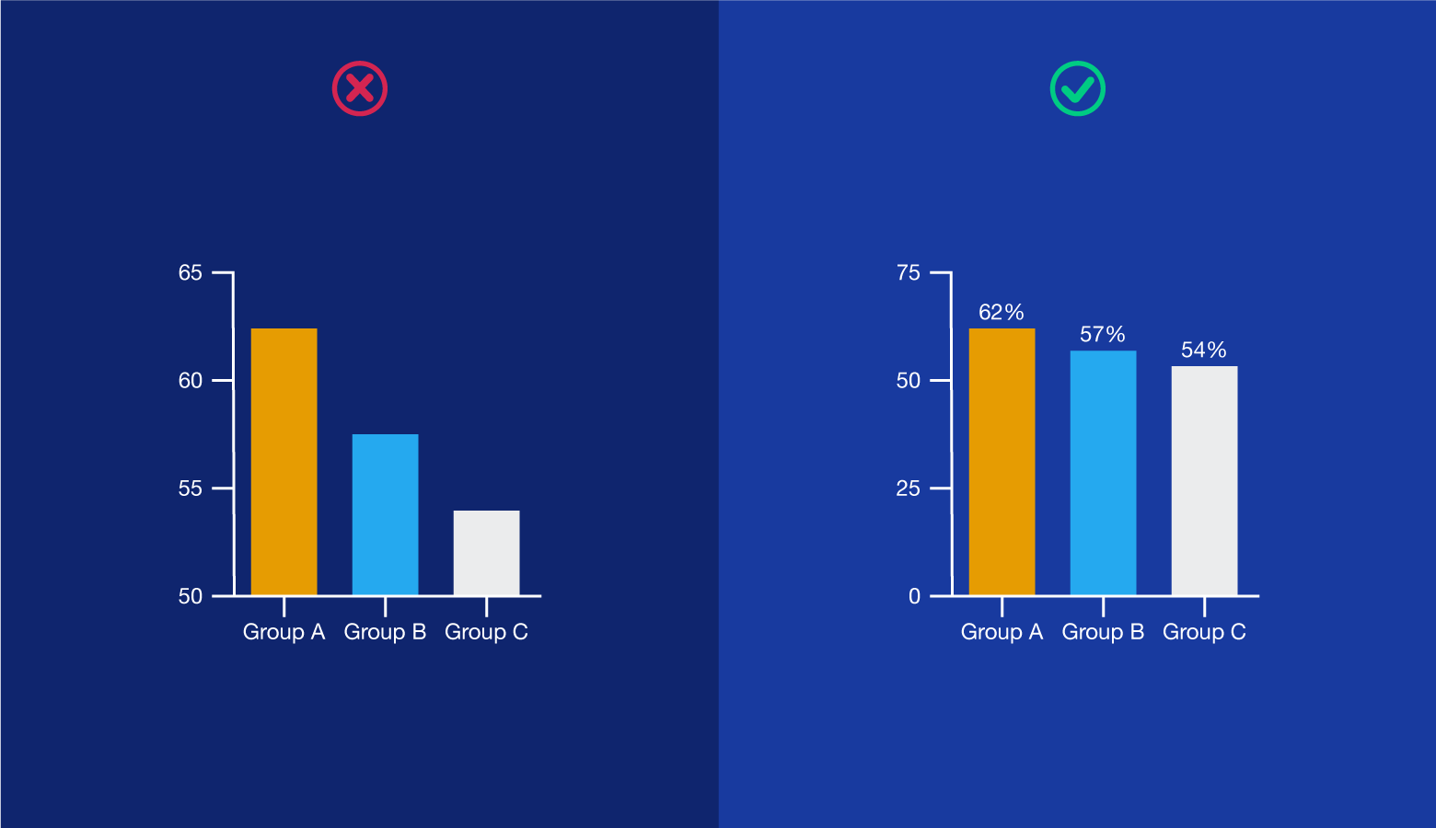

**Approach:**

Initial Flow:

1. The user will provide a file in the dashboard.

2. Triggers the controller.

3. Controller will send the file to the validator.

4. Validator checks the file and sends the request to the file reader.

5. FileReader reads the data from the excel file and sends the data to the graph generator for generating the graph.

6. By using that data, the Graph generator creates charts.(it may be pie chart, bar graph, line graph).The chart will be shown in the dashboard.



Detail Flow:

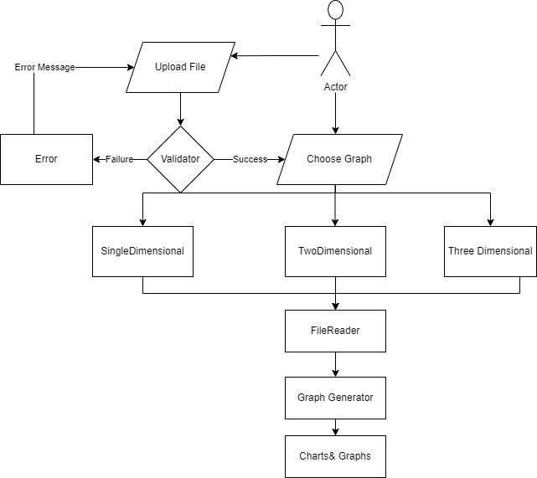

**Challenges:´**

Data Inputs and Algorithms Are Prone to Human Error

Data visualization can only be as good as the human inputs it makes use of, and these are prone to error. Professionals may use certain algorithms that highlight some information and do not make use of the others without understanding the differences in applications. They may employ a particular method as a one-size-fits-all approach to data visualization, which can lead to the misrepresentation of ideas.

To reduce human error, analysts must consider what makes each use case unique and make use of a system that can work toward their specific goals. Using artificial intelligence and machine learning technologies can also help reduce the need for human factors.

Data Can Be Oversimplified

Visualizations compress massive amounts of information into easy-to-understand graphs, scatter plots, and other basic imagery to help viewers comprehend them. As a result, some professionals tend to oversimplify things. They may leave out vital information by focusing too much on the visual appeal. As a result, the imagery can lead audiences to make false assumptions and conclusions. This can ultimately lead to faulty decision-making, which can harm businesses. Employing the help of data analytics consulting companies reduces the risk of oversimplification and can ensure that information is properly represented.

Reliance on Visualization Is Inevitable

More and more consumers are becoming dependent on visualizations to interpret data. They rely on imagery and aesthetics to draw conclusions at a glance. It’s an easy and effective way to absorb information, and it will likely stay relevant even as technology rapidly advances. However, the trend of consumers relying too heavily on visualization drives companies to use analytical tools to stay competitive.

**Benefits:**

Our eyes are [drawn to colors and patterns](https://www.tableau.com/learn/whitepapers/tableau-visual-guidebook). We can quickly identify red from blue, square from the circle. Our culture is visual, including everything from art and advertisements to TV and movies.

Data visualization is another form of visual art that grabs our interest and keeps our eyes on the message. When we see a chart, we [quickly see trends and outliers](https://www.tableau.com/reports/business-intelligence-trends). If we can see something, we internalize it quickly. It’s storytelling with a purpose. If you’ve ever stared at a massive spreadsheet of data and couldn’t see a trend, you know how much more effective a visualization can be. The uses of Data Visualization as follows.

**References**

**44 Types of Graphs Perfect for Every Top Industry.” n.d.** [***https://visme.co/blog/types-of-graphs/#business***](https://visme.co/blog/types-of-graphs/)***.***

**“5 Data Visualization Pitfalls.” n.d*.*** [***https://www.slideshare.net/qlik_arg/5-datavisualization-pitfalls***](https://www.slideshare.net/qlik_arg/5-data-visualization-pitfalls)***.***

**“8 Ways to Turn Good Data into Great Visualizations.”** [**-**](https://www.slideshare.net/qlik_arg/5-data-visualization-pitfalls) **n.d.** [***https://www.gooddata.com/blog/8-ways-turn-good-data-great-visualizations***](https://www.gooddata.com/blog/8-ways-turn-good-data-great-visualizations)***.***

**“9 Examples of Financial Graphs And Charts You Can Use For Your Business.”2018 .**[***https://www.datapine.com/blog/financial-graphs-and-charts-examples/***](https://www.datapine.com/blog/financial-graphs-and-charts-examples/)***.***